KMJ- KUST Medical Journal

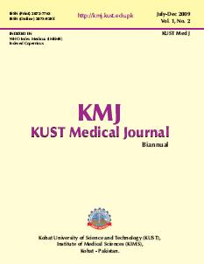

2009 Vol 1 No.2
A peer reviewed medical journal of the
KOHAT UNIVERSITY OF SCIENCE AND TECHNOLOGY (KUST), INSTITUTE OF MEDICAL SCIENCES (KIMS)
KOHAT-PAKISTAN

