To whom it may concern
This is to certify that the research article entitled “Personality Traits, Interpersonal Difficulties, and Mental Health Problems of Khat Addict and Non-Khat Addict: A Comparative Study”has been checked and scrutinized by the Ethical Committee of the Institute of Clinical Psychology, University of Management and Technology, Lahore, against the ethical criteria based on The American Psychological Association, The British Psychological Society and The Pakistan Association of Clinical Psychologists. The committee is of the opinion that this research complies with the standards accepted and recognized by the national and international organizations in all respects.
Prof. Dr. ZahidMahmood | 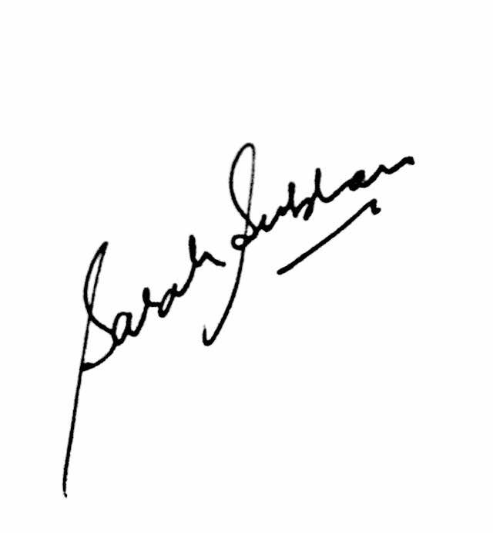  Ms Sara Subhan | 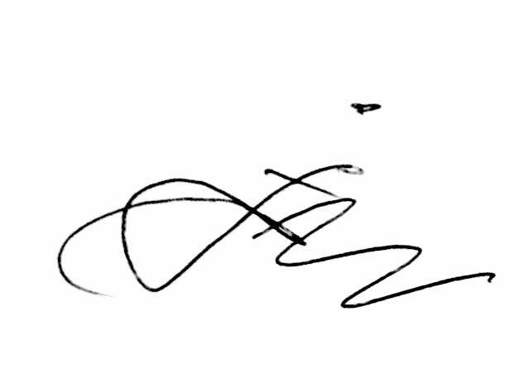  Dr. Rafiq Dar | Dr. Ivan Suneel Samuel
Chairman of Ethical Committee  Institute of Clinical Psychology,UMT | Assisstant Professor  Institute of Clinical Psychology,UMT | Assisstant Professor  Institute of Clinical Psychology,UMT | Head of Deapartment  Department of Psychology, Forman Christian College

