Dear Editor of KMUJ
Assalamo Alikum !
Thanks for your efforts and recommendations of the reviewers.
Here with I am submitting the revised copy of the article in the light of reviewer’s comments.
The point to point clarification is mentioned below.
Regarding Dr, Zahid Khan’s comments;
1. Spelling mistakes have been corrected.
2. Regarding the Sonologist who performed the Ultrasonograghy in our study, he is a senior radiologist with most of his experience in the field of ultrasonology having more than 20 years experience of ultrasound. All the cases were performed by a single radiologist who was provided with the clinical information of suspected acute appendicitis. This information has been added to the material and method section. His name has been added to the outher’s list as No.04.
3. The references have been re-written with correction of spellings.
Regarding Dr. Suraya Zafars comments;
1. The title in the opinion of authors is quite relevant and gives a general idea about the content of the study.
2. The pictures of ultrasonically normal and abnormal appendix have been added with relevant information of findings on the images. The patient’s identity has been concealed for ethical and medico-legal implications.
3. Criteria of clinical diagnosis of acute appendicitis have been added in section of methodology.
4. Inclusion and exclusion criteria’s are more clearly mentioned in methodology section.
5. Ultrasound technique is also mentioned more clearly in methodology section.
6. Criteria of positive and negative category are mentioned in methodology section.
7. Regarding the international references, yes she is right that the latest reference quoted is that of 2006; this is because of the reason that in the modern world there is more and more use of CT for the diagnosis of the Acute appendicitis which is not operator dependant and has a wide field of view, has the sensitivity and specificity reaching 100 percent and the ultrasound is mainly being depended in the 3rd world for all pre-operative cases. However recent Local references of 2007 and 2010 were added at no.1 and no. 3 respectively.
8. The inclusion and exclusion criteria depend on the local circumstances and study design by the authors and in our opinion it is not necessary to quote any reference for exclusion criterion. The reason why we excluded the cases of perforated appendicitis with generalized peritonitis and appendicular abscesses and masses is because their presentation and management is different.
9. The typographical error of sinology has been corrected.
10. In lines 5-6 of the 2nd para of “methodology” section it is already mentioned that all the 21% false positive cases were surgically proven. Regarding the comments of the unknown reviewer;
11. The role of authors was defined in the Authors Declaration form. However the outher’s declaration form has been re-submitted.
12. Yes we agree that this article does not invent something new but it is also an established and acceptable practice to re-evaluate the results of previous studies as well as current practices, in different /local circumstances and to evaluate their effectiveness in different periods of time. With changing trends of modern medical science it is also a good idea to evaluate the current practices and their usefulness against newly emerging practices in terms of availability of facilities and their cost-effectiveness. With this in mind; in the author’s opinion this study has proven its worth.
13. Yes we agree that the majority of references are old but the aim of the study is not to load it with the references. There is sufficient reference material i.e. 23 references with 6 within last 10 years are sufficient to prove that the subject is interesting and has been previously worked upon.
14. Results and objectives have been matched appropriately.
With these comments from us we thank you for giving us chance to revise and at some points explain our view point. We will be more than happy to clarify any more queries or suggestions by the reviewers or editorial board if necessary.
Regards.

Yours truly,
Dr. Fazal Ahmad

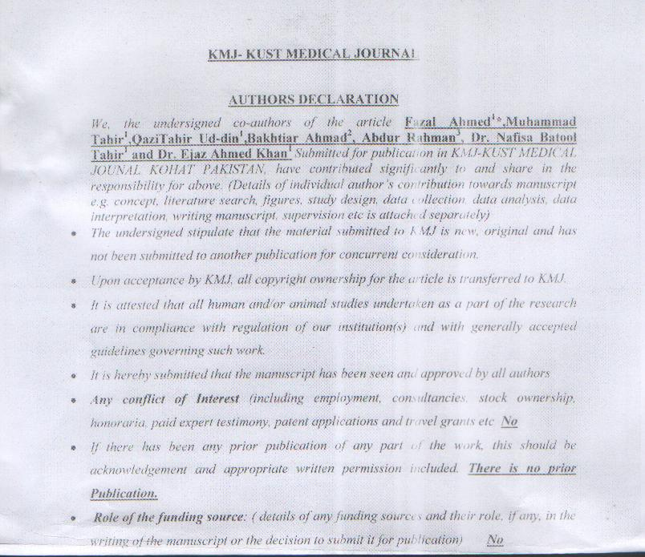
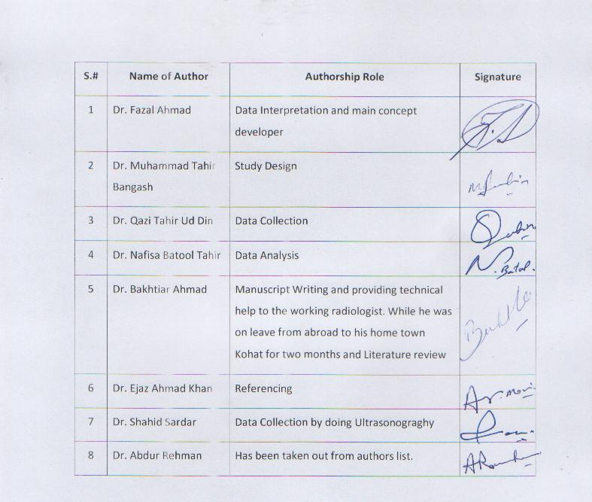

Ultrasonograghy: A good aid to the clinical diagnosis of Acute-Appendicitis
Fazal Ahmed1*, Mohammad Tahir¹, , Qazi Tahir Ud-din¹, Ejaz Ahmed Khan2, Nafisa Batool Tahir³ , Shaid Sardar⁴ and BakhtiarAhmad⁵
Keywords: Ultrasonography, acute appendicitis, histopathology, graded compression
ABSTRACT
OBJECTIVES: Our aim was to evaluate the value of Ultrasonography in the diagnosis of acute-appendicitis, in clinically suspected cases.
METHODOLOGY: This prospective observational study was executed to evaluate the role of ultrasound in the diagnosis of acute appendicitis in which the ultrasound findings were compared with histopathological outcome of the case, which was taken as gold standard. This study was carried out from Feb-2009 to Nov-2011. A total of 150 patients were included in the study. All patients had a clinical suspicion of acute-appendicitis. Age ranged from 11 to 60 years. There were 112 male and 38 female patients. In the radiology department color Doppler ultra sound machine, ACCUCIE TOSHIBA with a 7.5 MHz, abdominal probe was used. All the exams were performed by a single senior radiologist.
RESULTS: On the basis of ultrasonography 100 patients were labeled as Positive for acute-appendicitis and 50 patients were labeled as negative for acute-appendicitis. Out of negative patients 5 were explored later on because of persistent pain and progressing symptoms and a diagnosis of acute-appendicitis was confirmed on histopathology.
CONCLUSION: Present study concluded that in clinically suspected cases of acute-appendicitis the use of ultrasonography is essential to make, exclude or establish an alternate diagnosis. Because of its cost effectiveness we recommend it as an essential screening tool in clinically suspected cases of acute-appendicitis.
- Assistant Professor Surgery, KMU Institute of Medical Sciences Kohat,
- Assistant Professor Community Medicine, KMU Institute of Medical Sciences Kohat,
- Assistant Professor Medicine, KMU Institute of Medical Sciences Kohat,
- Assistant Professor Radiology, KMU Institute of Medical Sciences Kohat,
- Consultant Radiologist, Medical Imaging Department, King Abdul Aziz Hospital
(National Guard Health Affairs), Al Ahsa31982Kingdom of Saudi Arabia
Correspondence Address: surfazal@gmail.com

INTRODUCTION:
With the introduction of ultrasound in late 20th century, it has revolutionized the diagnostic armamentarium of many abdominal surgical conditions, specially the emergency cases like acute appendicitis, because of its wide and ready availability, low cost, no radiation risk and continuous technological improvement in quality¹. Although the CT scan is considered the diagnostic modality of choice at many modern hospitals and medical practices, with its new helical scanners which can diagnose or exclude acute appendicitis with high sensitivity and specificity, the ultrasound provides the most practical method of imaging investigation in a peripheral hospital setting with restricted availability of costly diagnostic tools such as a modern CT Scan Machine. The graded compression technique has significantly improved sensitivity and specificity of ultrasound and it is recommended as a routine test in the investigation of acute appendicitis². Sometimes Plain X-rays abdomen and urine analysis are done to further exclude the urinary causes of right loin pain; however they have low sensitivity and specificity in making a positive diagnosis of acute appendicitis. Lab. Investigations like TLC and DLC are also helpful in the diagnosis of acute appendicitis³. In the last two decades, sonography has shown promising results in the diagnosis of acute-appendicitis. It helps in establishing the dignosiss of acute appendicitis and at times helps in excluding an alternate diagnosis. On ultrasonography the presence of normal appendix excludes appendicitis to a great certainty (Fig 1). Acutely inflamed appendix is non-compressible, shows increased thickness, dilatation and periappendiceal inflammation and on color Doppler shows increased vascularity (Fig 2). The inaccurate negative reports sometimes may be due to increased bowl gases, stool or obesity. In the past, studies have been done on routine use of ultrasonography in patients with pain right iliac fossa and these had revealed high sensitivity and specificity as compared to clinical judgment, thusreducing negative explorations. Now-a-days new ultrasound machines are very accurate in picking up the signs of appendicitis. Sonography has proved its cost effectiveness by minimizing unnecessary operations. This study was carried out at a peripheral district headquarter hospital with limited diagnostic facilities, to evaluate the role of abdominal Ultrasound in the clinically suspected cases of acute appendicitis.

METHODOLOGY:
In present study, author selected 150 patients who had presented with pain right iliac fossa and clinical diagnosis of acute appendicitis was made on history and physical examination which included pain starting in paraumblical area and then shifting to right Illiac fossa, nausea vomiting and tenderness in right iliac fossa. Out of these one hundred patients, 112 were males and 38 were females and their age ranged from 11---60 years. Prompt surgical intervention was carried out in all those cases, where the ultrasonic diagnosis of acute appendicitis was established. We excluded from study all the cases, which on presentation had appendicular mass or had generalized peritonitis from perforated appendix. All the patients underwent sonographic examination with the help of ACCUCIE TOSHIBA machine, with a 7.5 MHz high resolution probe. Complete examinations were performed by a single senior radiologist having experience of more than 20 years of working with ultrasound, as part of his routine hospital work and he was provided with the information of clinical suspicion of acute appendicitis before performing the study. 105 patients were operated, 100 from ultrasound positive category and 5 from ultrasound negative category as they were having persistent pain and progressive symptoms. All 105 specimens of appendix were submitted for histopathology study. Data analysis carried out by using SPSS version 13.0 and the results were compared with national and international studies. The following criteria were considered for the sonographic diagnosis or exclusion of acute appendicitis.
1: Non visualization of appendix suggestive of negative study.
2: On visualization of appendix the diameter equal to or less than 6mm considered as normal.
3: Demonstration of enlarged, tubular, blind ending structure with wall thickness of 3.0 mm or diameter of 7.0 mm or more as positive diagnosis of acute appendicitis.
4: Loss of wall layers is equal to gangrenous appendicitis.
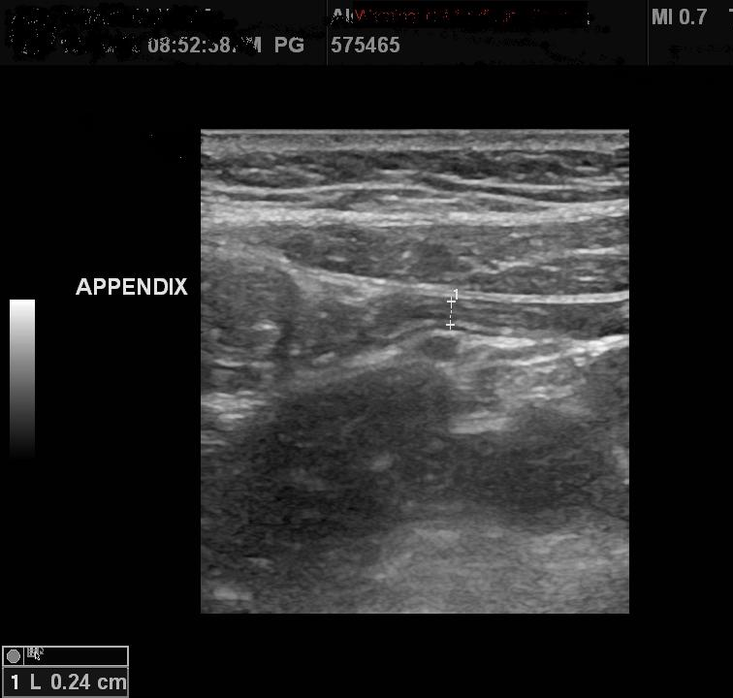
Figure 1. A 16 years male patient with normal appendix on ultrasound. Ultrasound shows a well- defined smooth walled tubular structure (arrows) with diameter less than 6mm and no peri-appendiceal inflammation.

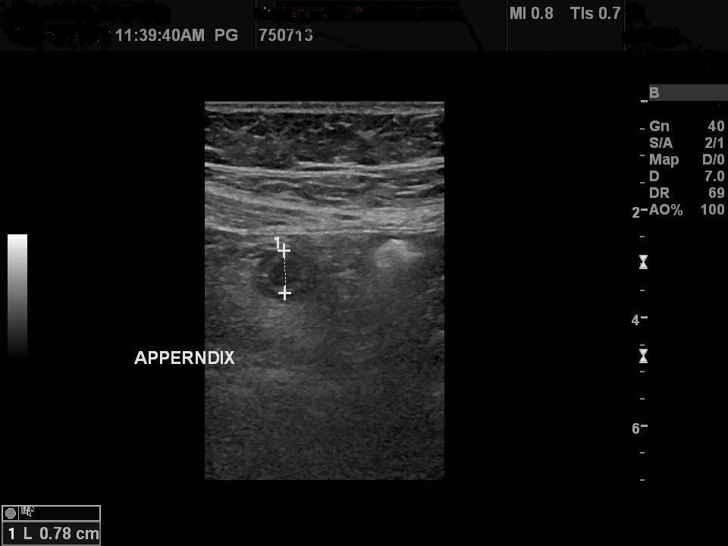
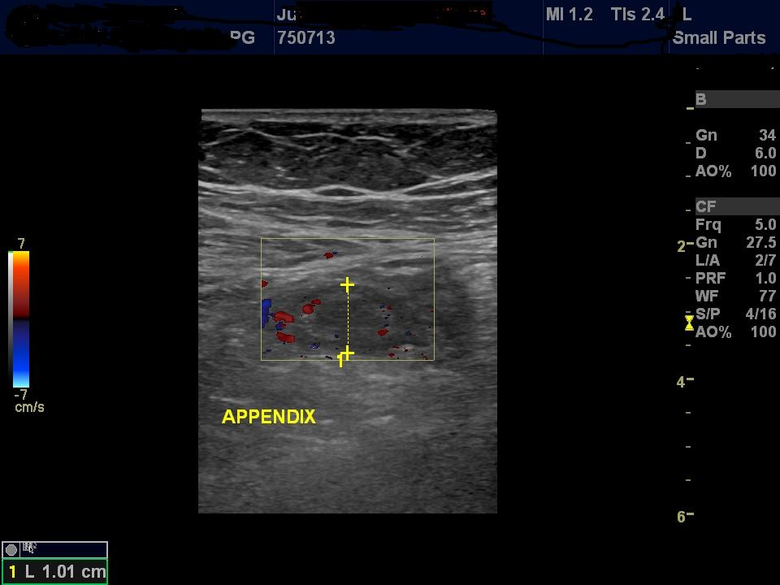
Figure 2 A (top) Acute appendicitis in a 19 years male on ultrasound. There is an enlarged appendix with thick wall, increased diameter, on this cross sectional image shows target sign. (Bottom) Periappendiceal inflammation and increased vascularity on color Doppler.
RESULTS:
The study was conducted on 150 patients, out of whom 100 were positive for acute appendicitis on ultrasonography while 50 were negative, the sensitivity and specificity was tested in these selected cases for the ultrasonography.
Table I: Diagnosis of 100 ultrasonography positive cases of acute appendicitis.
Diagnosis | No Of Cases | Percentage of Cases
Acute Appendicitis | 79 | 79%
Ascarasis | 15 | 15%
Nil Diagnosis | 6 | 06%

Results show that 79 % cases were diagnosed as acute appendicitis histopathologically which were reported as acute appendicitis on sonography while 21% were false positive for acute appendicitis (Table I).
Table II Diagnosis of 50 cases which were ultrasound negative for acute appendicitis.
Diagnosis | No Of Cases | Percentage of Cases
Acute Appendicitis | 05 | 10%
Acute Cholecystitis | 06 | 12%
Right Ovarian Cyst | 03 | 06%
Mesenteric Lymphadinitis | 04 | 08%
Right Ectopic gestation | 01 | 02%
Right Ureteric Calculus | 12 | 24%
Ascariasis | 05 | 10%
Nil Diagnosis | 14 | 28%

Out of 50 cases reported as negative for acute appendicitis, 5 (10%) were operated later and were diagnosed as acute-appendicitis confirmed histopathologically while 90% cases were true negative for appendicitis ultrasonographically as they were managed for other diseases.
(Table II)

Table III: Diagnosis of all 150 cases selected for study.
Diagnosis | No Of Cases | Percentage of Cases
Acute Appendicitis | 84 | 56.6%
Acute Cholecystitis | 06 | 04%
Right Ureteric Calculus | 12 | 08%
Right Ovarian Cyst | 03 | 02%
Right Ectopic gestation | 01 | 0.66%
Mesenteric Lymphadenitis | 04 | 2.66%
Ascariasis | 20 | 13.3%
Nil Diagnosis | 20 | 13.3%

In total 84 cases were diagnosed as acute appendicitis histopathologically out of which 79 were true positive and 05 were false negative showing a sensitivity of 94 % for ultrasonography in diagnosing acute appendicitis where as the specificity of this investigation was 68.18 %
(Table III).

DISCUSSION:
The diagnosis of acute appendicitis mainly depends upon patient history and surgeon’s clinical examination alone in majority of the typical cases of acute appendicitis. However in atypical presentations, in extreme of ages and in pregnant women, author needed help from investigations^{4,5,6}. Sometime the inflammation is confined to the tip of appendix and the organ may not be visualized^{7,8} sonography. In present study too, one such case was missed and later on operated because of continuing and progressive symptoms and proved to be one of the false negative case. During pregnancy the clinical diagnosis of acute appendicitis becomes very difficult especially in the third trimester. In these cases, sonology is done in left lateral decubitus position thereby displacing enlarged uterus to the left and making appendix visualization possible¹¹. In children and in geriatric patients, sonology is of special help because the symptoms are very vague¹². In present study, data was not analyzed the age and sex of selected patients, because this was not the present study aim, yet author did come across with pregnant ladies, young children and above 50 years patients where ultrasound was extremely helpful in diagnosing acute appendicitis and or establishing an alternate diagnosis. Computed tomography has definitely increased the diagnostic accuracy¹³ but its availability varies from place to place and moreover it is an invasive diagnostic tool with a reasonably high cost. Ultrasonography has been used extensively as a first line diagnostic tool in clinically suspected cases of acute appendicitis. Since 1986 many workers studied the value of ultrasonography in acute appendicitis and reported its enhanced diagnostic accuracy^{14,15,16}. Authors studied the role of ultrasonography though a different angle, but the results are comparable. The procedure of present study was different from all others so far published literature on the subject. Author is of the opinion that prompt surgical intervention in all sonographically diagnosed cases of acute appendicitis, irrespective of Alvarado scoring made the results of ultrasound much more reliable and the values of sensitivity and specificity of this investigation in acute appendicitis patients are much more authentic.
In past, when clinical suspicion of acute appendicitis was the sole diagnostic criteria, surgeons used to perform appendicectomies on border line cases to avoid the complication associated with delayed or missed diagnosis of acute appendicitis. This protocol can lead to up to 20% of negative appendectomies¹⁷. This protocol and the ratio of negative appendectomies were acceptable all over the world till the availability of ultrasound, CT scan and laparoscopy, which revolutionized this concept, by reducing the ratio of negative laporatomies.
The previous gray scale ultrasound machines with only 3.50 MHz were not able to demonstrate sonographic signs of acute appendicitis. In this study high resolution probes of 7.50 MHz with graded compression technique for the demonstration of appendicitis were used. Graded compression method was able to reduce the distance between the probe and appendix, thus demonstrating signs of inflammation by displacing bowl loops. The effectiveness of ultrasonography in the diagnostic armamentarium of clinically suspected cases of acute appendicitis is now well established. In many studies the sensitivity has been reported in the range of 85-94%^{15,19,20}. Present study showed the sensitivity of 94% of ultrasonography in diagnosing acute appendicitis.
This investigation has another very important role in clinically equivocal cases where it is helpful in establishing an alternate diagnosis^{9,21}. In this study too, authors were able to make an alternate diagnosis in 21% of originally suspected cases for acute appendicitis. Many of these patients with alternate diagnosis did not need surgery and ultrasonography alone reduced the number of negative appendectomies.
A modern ultrasound machine and an experienced sinologist is considered as primary requisite for such type of investigational study. Authors have both facilities available; otherwise it would not have been possible to be so confident for surgeon to operate on the basis of ultrasound report only. Some of the previous reports^{22,23}, which have shown less accuracy for this investigation, were actually having the operator problem.
CONCLUSION:
From present study, it is concluded that ultrasonography for pain RIF is cost effective, readily available and non invasive technique, which gives the diagnosis of acute appendicitis in minutes, thus rapid decision is made for surgery especially in children, pregnant women and in geriatric patients.
Although this was not the aim of the study, yet is a by product of the study it was also concluded that this investigation is also helpful in establishing an alternate diagnosis. Looking into the above mentioned benefits and a very high sensitivity of ultrasonography, authors recommend it as a first line investigation in all patients with pain RIF.
REFERENCES:
- Baensler EHL Jeffery J.R.B. Liang FF. Sonography in patients with suspected acute appendicitis. Value in establishing alternative diagnosis. AJR, 1989; 152: 49- 52.
- Boubalos a diagnosis of epigastric appendicitis based on sonographic findings. AJR. 1992; 159- 222.
- Chan I, Bicknell SG, Graham M, Utility and Diagnostic accuracy of songraphy in detecting appendicitis in a community hospital. Am J Roentgen. 2005; 186(6); 1809-12.
- Dholia KR, Baloch I, Shaikh S A, Soomro S H, Abro A. Total and differential leucocyte count (TLC and DLC) in cases of acute appendicitis. a study of 200 cases at Chandka Medical College Hospital Larkana. Med Channel Apr - Jun 2010; 16(2):284-6
- Franke C, Bohner H, Yang Q, Ohmann C, Rohr HD. Ultrasonography for the diagnosis of acute appendicitis; results of a prospective multicenter trial. World J Surg 1999; 23(2); 141-146.
- Haydan CK. Kuchelmeister J. Liposcamp TS. Sonography of Ac. App in child hood. Perforation verses non perforation. J. ultrasonography Med 1992; 11: 209-16.
- Lee JH, Jeong YK, Hwang JC, Ham SY, Yang SO. Graded compression sonography with adjutant use of posterior compression technique in the sonographic diagnosis of acute appendicitis. AJR.2002; 178(4):863-8.
- Lee JH, Jeong YK, Park KB, Park JK, Jeong AK, Hwang GC. Operator-dependent techniques for graded compression appendicitis. AJR. 2005; 184(1); 91-7.
- Lee S, Walsh AJ, Ho HS. Computed tomography and ultrasonography do not improve and may delay the diagnosis and treatment of acute appendicitis. Arc Surg. 2001; 136(5); 556-62.
- Lewis RF Holeroft Boeyjetal Appendicitis; : A critical review of low cases. Archieves Surg 1975; 10: 677- 84.
- Lim HK Bar. SH Se OGS. Diagnosis of Acute appendicitis in pregnant women Value sonography. AJR. 1992; 159: 539-32.
- Mardan M A A, Mufti TS, Khattak I U, Chilkunda N, Alshayeb A A, Mohammad A M, Rehman Z. Role of ultrasound in acute appendicitis. J Ayub Med Coll Jul - Sep 2007;19(3):72-9.
- Nghiem HV. Jeffery JRB Acute appendicitis confirmed to appendiceal tip. JM ultrasonography Med 1992; 11: 205-7.
- Ooms HW, Koumans RK, Ho Kang you PJ, Puylaert JB. Ultrasonography in the diagnosis of acute appendicitis. Br J Surg. 1991; 78(3); 315-8.
- Poole G V. Appendicitis. The diagnostic challenge conclusive. Am Surgeons 1998; 5 4: 609-12
- Puylaert JB. Acute appendicitis: US evaluation using graded compression. Radiology. 1986; 158(2): 355-60.
- Qureshi I A, Tarin B A, Shafiq M. Role of Ultrasonography in clinically suspected cases of Acute Appendicitis. Pak Armed Forces Med J Dec 2001;51(2):90-3.
- Rettenbacker T, Hollerweger A, Macheiner P, Gritzmann N, Daniaux M, Schwamberger K et al, Ovoid shape of the vermiform appendix, a criterion to exclude acute appendicitis- evaluation with US. Radiology. 2003; 226(1); 95-100.
- Ripollés T, M J Martinez-Perez, V Morote and J Solaz. Diseases that simulate acute appendicitis on ultrasonography. Br. J. Radial, 1998; 71(841): 94-8.
- Rodriguez DP, Wargas S, Callahan MI, Zurakowski D, Taylor GA, Appendicitis in young children; imaging experience and clinical outcomes. AJR, 2006; 186(4); 1158-64.
- Schuler JG, Shortsleeve MJ, Goldenson RS, Perez-Rossello JM, Perlmutter RA, Thorsten A Is there a role for abdominal computed tomographic scan in appendicitis? Arch Surg 1998;133 (4); 373-6
- Stavros. AT RAPP. CL. Johson. KK sonography of the normal appendix. RSNA exhibit 1993.
- Zielke A, Hasse C, Sitter H, Rothmund M, Influence of ultrasound on clinical decision making in acute appendicitis: a prospective study. Eur J Surg 1998; 164(3):201-9.

